Mechanical Workshop
M2 Homework

Q1) fill in the blanks, using the following words:

Fixed Metric thimble Micrometer Depth
Metrology Divisions Inside Imperial stem
- --------------------------is used to measure the smaller dimensions.
- The Vernier callipers is used to carry out measurement for-----------------, -------------------------and depth dimensions.
- The accuracy of any measuring tool depends on the number of -----------------in its scale.
- The main scale in the vernier callipers is-------------------while the vernier scale is movable.
- The main two system of measurements are------------------and-----------------.
- The science that deals with the practical and theoretical aspects of measurements is called ---------------------------.
- The part which used to measure the depth dimension in vernier caliper is the -------------------.
- To close the micrometer jaws one millimetre we need to rotate the ---------------------two full turns.

Q2) write (T) for true and (F) for false to the following statements:

- The bended ruler gives an accurate measurement. ( )
- The rotating thimble in micrometer is subdivided into 50 equal divisions. ( )
- We can use the steel ruler edges as a scriber. ( )
- The vernier calipers are used to measure the depth dimension only. ( )
- The Yard is the basic unit in the imperial system. ( )
- One of the main parts of the vernier caliper is the sleeve. ( )
- If we want to get an accurate measurement from any measuring instrument we have to look from the side. ( )
- The Vernier caliper with 10 divisions in Vernier scale is accurate to ±0.1mm( )

Q3) read the following measurements:

a) reading is:
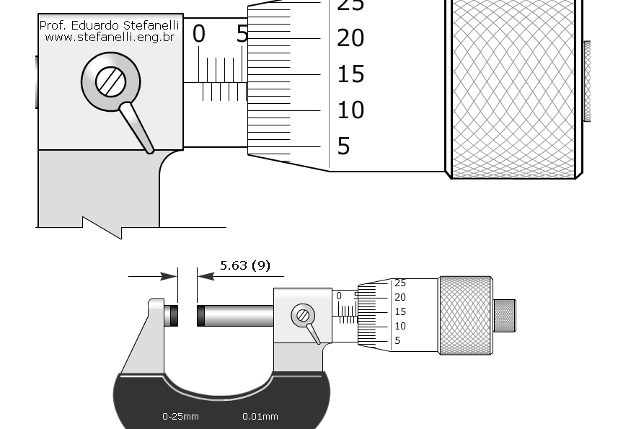

b) reading is: | 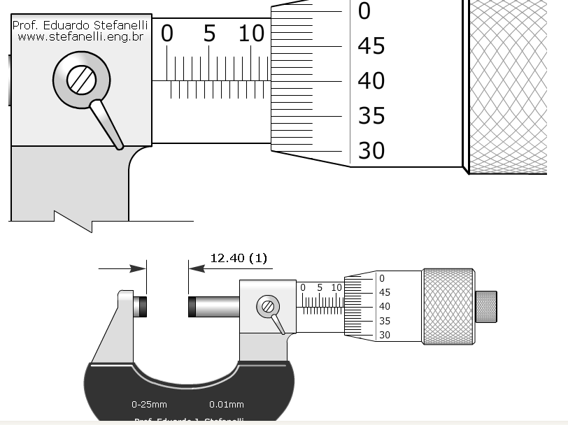
c) reading is: | 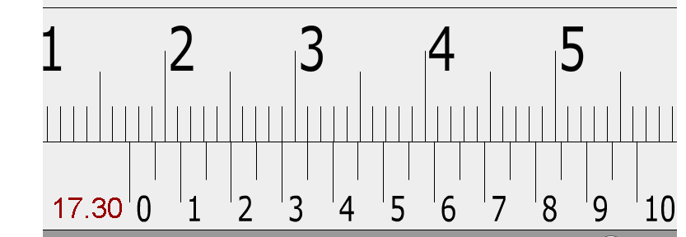
d) reading is: | 