

Technology Exploration-I

Module 2:
Levers

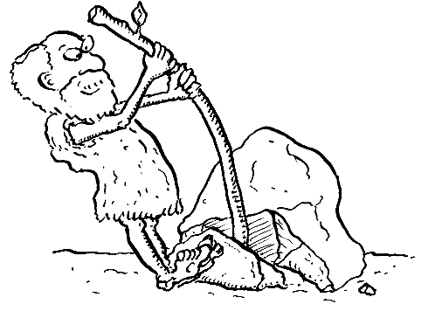

PREPARED BY

Academic Services

August 2011

© Applied Technology High Schools , 2011

Module 2: Levers
Module Objectives

After the completion of this module, student should be able to:

- Identify levers.
- Calculate the mechanical advantage of a lever.
- Calculate forces and lengths related to levers.
- Distinguish and explain the difference between the three classes of levers.
- Give real life examples of the different types of levers.

Module Contents

No. | Topic | Page
2.1 | Introduction to Levers | 3
2.2 | Mechanical Advantage of Levers | 3
2.3 | Classes of Levers | 5
2.4 | Activities | 7
2.5 | Practical Tasks | 9
2.6 | Levers Worksheet | 11
2.7 | Additional Resources | 12

2.1 Introduction to Levers
In the previous module you have studied the different types of simple machines; lever is one of the most commonly used simple machines.
Definition: A lever is a rigid bar that is used to transfer force. With a pivot or sometimes called fulcrum, the lever can be used to change force that is applied (effort) by changing the position of the pivot along the lever (refer to Fig. 2.1 below). EFFORT, PIVOT (Fulcrum) and LOAD are the three features that are common in every lever.
- Pivot is the point on which the lever balances (or pivots).
- Load is the weight or resistance that needs to be overcome.
- Effort is the force you apply to the lever.
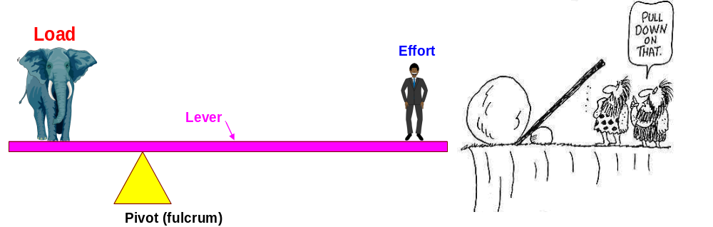
Fig. 2.1: The three features of the lever are effort, load and pivot.
2.2 Mechanical Advantage of Levers
The mechanical advantage of a machine is the ratio of the output force produced by a machine to the applied input force. In a lever, the ideal mechanical advantage (MAi) of a lever is the ratio of the length of the effort arm (L_{E}) to the length of the load arm (L_{L)}. It can be calculated using the following formula:
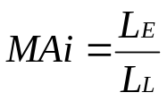 …(2.1)
The length of effort arm and the length of load arm are illustrated in Fig. 2.2.

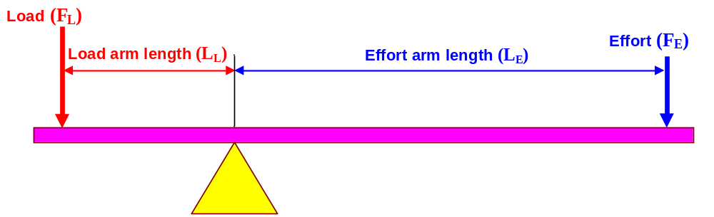
Fig. 2.2: The ideal mechanical advantage is the ratio of the effort arm length to the load arm length.
The amount of effort needed to lift a given load with any lever can be calculated using this formula:

F_{E} x L_{E} = F_{L} x L_{L} … (2.2)
Where,

F_{E}: Effort force
L_{E}: Effort arm length
F_{L}: Load force
L_{L}: Load arm length

Example:  Referring to Fig. 2.3, calculate the following:  1. The effort needed to balance the 400 N load given that the load arm length is 0.4 m and the effort arm length is 2 m.  2. The ideal mechanical advantage (MAi)  Solution:  1. From equation (2.2), calculate the effort needed (F_{E}) as follows:  F_{E} x L_{E} = F_{L} x L_{L} | 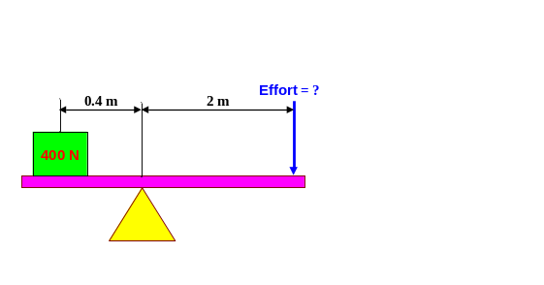  Fig. 2.3: The effort force can be calculated given the load force, the load arm length and the effort arm length.
F_{E} x 2 m= 400 N x 0.4 m
F_{E} = 400 N x 0.4 m/ 2 m
F_{E} = 80 N
2. From equation (2.1) calculate the mechanical advantage as follows:
MAi = L_{E} / L_{L}
MAi = 2 m/ 0.4 m
MAi= 5
If the effort arm length is 5 times the load arm length, then the effort force required is 1/5 the load force; i.e. to decrease the effort force, increase the effort arm length.
2.3 Classes of Levers  There are three classes of levers, namely;  - First class  - Second class  - Third class  2.3.1 First Class Levers  There are three classes of levers.  First class levers have the fulcrum (pivot) positioned between the effort and the load as illustrated in Fig.2.4. A clear example of the first class levers is a seesaw shown in Fig.2.5. | 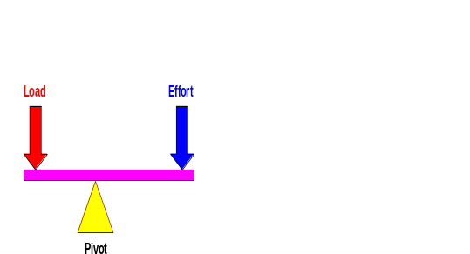  Fig.2.4: In first class levers, the fulcrum (pivot) is positioned between the effort and the load.  .
Can you think of other examples?  . | 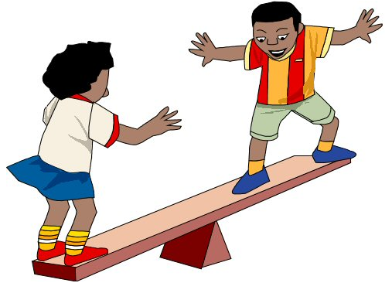  Fig.2.5: Seesaw is a clear example of first class levers
2.3.2 Second Class Levers
In the second class levers the load is positioned between the fulcrum (pivot) and effort as illustrated in Fig.2.6. A typical example of second class levers is the nut cracker shown in Fig. 2.7.

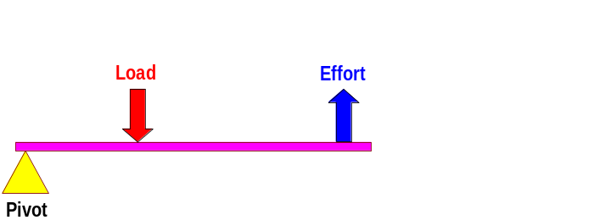
Fig. 2.6: In second class levers the load is positioned between the effort and the fulcrum (pivot).
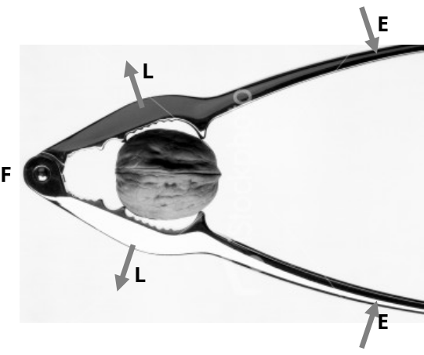
Fig. 2.7: Nut cracker is a second class lever.

2.3.3 Third Class Levers

Third class levers have the effort positioned in the middle between the load and pivot as illustrated in Fig. 2.8. A typical example of third class levers is tweezers shown in Fig. 2.9. In third class levers the effort force is more than the load force, but the effort traveled-distance is less.
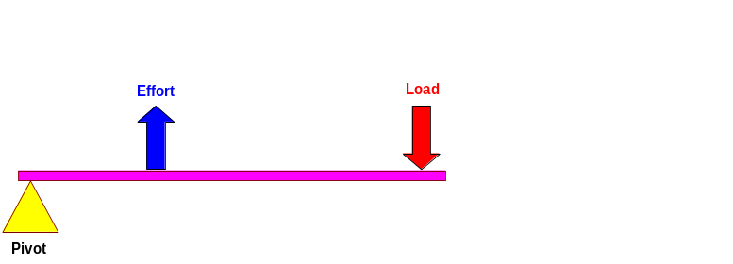
Fig. 2.8: In third class levers the effort is positioned between the load and the fulcrum (pivot)

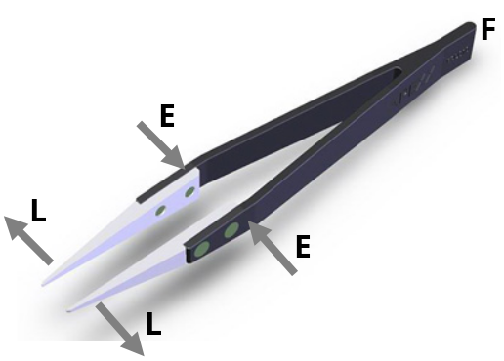
Fig. 2.9: Tweezers are typical example of third class levers.

2.4 Activities  1. Watch the hammer video and determine which class of levers it is:  _____________________________ Identify the pivot, the load and the effort. | 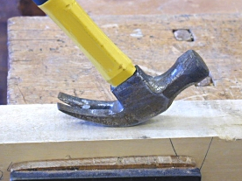  Fig. 2.10: Hammer
2. Watch the can crusher video and determine which class of levers it is:  _____________________________  Identify the pivot, the load and the effort. | 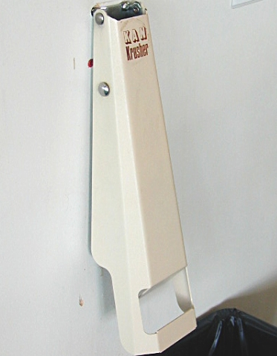  Fig. 2.11: Can crusher.
3. Refer to the scissors image shown in Fig.2.12 and determine which class of levers it is:  _____________________________  Identify the pivot, the load and the effort. | 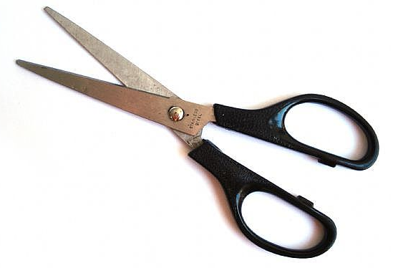  Fig. 2.12: Scissors.
4. Refer to the wheelbarrow image shown in Fig.2.13 and determine which class of levers it is:  _____________________________  Identify the pivot, load and effort.  5. Refer to the fishing rod image shown in Fig.2.14 and determine which class of levers it is:  _____________________________  Identify the pivot, the load and the effort. | 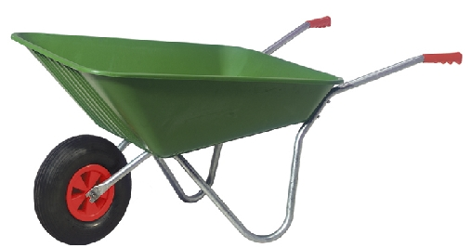  Fig. 2.13: Wheelbarrow.    Fig. 2.14: Fishing rod.
6. Refer to the shovel image shown in Fig.2.15 and determine which class of levers it is:  _____________________________  Identify the pivot, the load and the effort. |   Fig. 2.15: Shovel.
2.5 Practical Tasks  2.5.1 Task 1  Refer to the building instructions booklet to build the lever “A1” shown in Fig. 1.16. Determine which class of levers it is:  _____________________________  Identify the pivot, the load and the effort.  Calculate the ideal mechanical advantage.  _____________________________  _____________________________  _____________________________  _____________________________  _____________________________ | 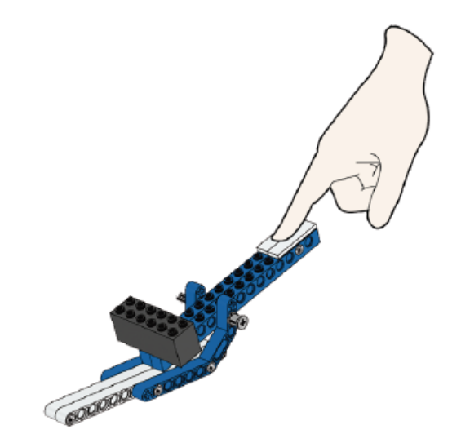 Fig. 1.19: Lego lever A1.
2.5.2 Task 2  Build the lever “A2” shown in Fig. 1:20. Determine which class of levers it is:  ____________________________  Identify the pivot, the load and the effort.  Calculate the mechanical advantage.  ____________________________  ____________________________  ____________________________  ____________________________  ____________________________  ____________________________ | 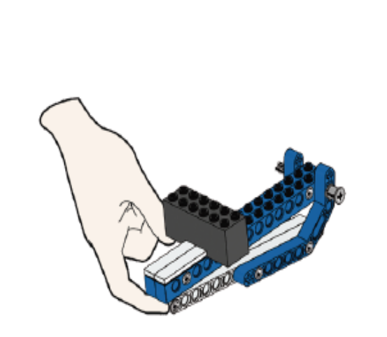  Fig. 1.20: Lego lever A2.
2.5.3 Task 3  Build the lever “A3” shown in Fig. 1:21. Determine which class of levers it is:  ____________________________  Identify the pivot, load and effort.  Calculate the mechanical advantage  ____________________________  ____________________________  ____________________________  ____________________________  ____________________________  _________________________  _________________________ | 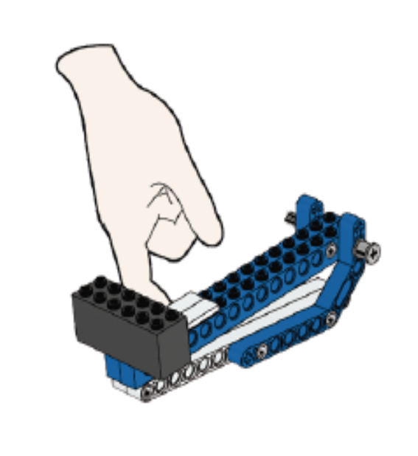  Fig. 1.21: Lego lever A3.

Worksheet-1
1. Find the following words:

Force Load Pivot Fulcrum Effort Levers

F V M M J I J M P
T O X U C V Q O Z
P F R R T V K B L
P T D C Z X H E T
W O U L E X V A R
W V D U H E M L O
F I A F R Q P G F
Z P O S P Z I W F
K C L O M V Y Z E
2. Visit the website mentioned below and try to identify 5 different levers in the house mentioning their class http://www.edheads.org/activities/simple-machines/
- ___________________  - ___________________  - ___________________  - ___________________  - ___________________ | Class: ___________________  Class: ___________________  Class: ___________________  Class: ___________________  Class: ___________________
3. Search the internet for levers in the human body; select one lever and in your teacher blog do the following:
- Describe that lever and state its class.
- Upload a sketch or an image of that lever indicating the load, effort, and pivot.
- Include the link to the source of your information.

Worksheet 2:
- Fill in the blank:
Pivot load effort first Second third force Effort arm length Advantage Direction Load arm length
  - A lever is a rigid bar that is used to transfer ………….. with a pivot.
  - A heavy stone to be moved away, the stone is an example on …………….
  - The Mechanical Advantage of a lever is ……………………….........../……………………………………….
  - The applied force on the lever is called ………………………..
  - When the effort is located between the load and the pivot this is a ……………….. class lever.
  - When the Pivot is placed between the load and the Effort this is levers ……………….. class

- Calculate the following (show the unit):
- Effort and MAI: Sara has been given a task to move a rock of 500 N where the load arm length is 3 and the effort arm length is 4.

- Load arm length: with a load of 200 N and an effort of 600 N where the effort arm length is 2m.

2.7 Additional Resources
http://www.msichicago.org/fileadmin/Activities/Games/simplemachines/

