

**Technology Exploration**

**Homework5**

**Q/Write on each picture the type of simple machine it is**



MCj02960780000[1]j0278882

MCj02957660000[1]__________ ____________ ______________

MCj02320630000[1]

MMj03368570000[1]

________________

and _____________ _____________ ____________

and _____________

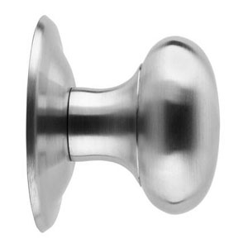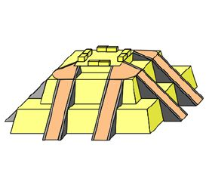

_______________ _______________ ______________

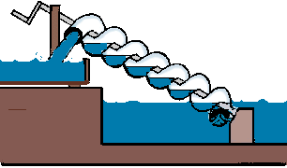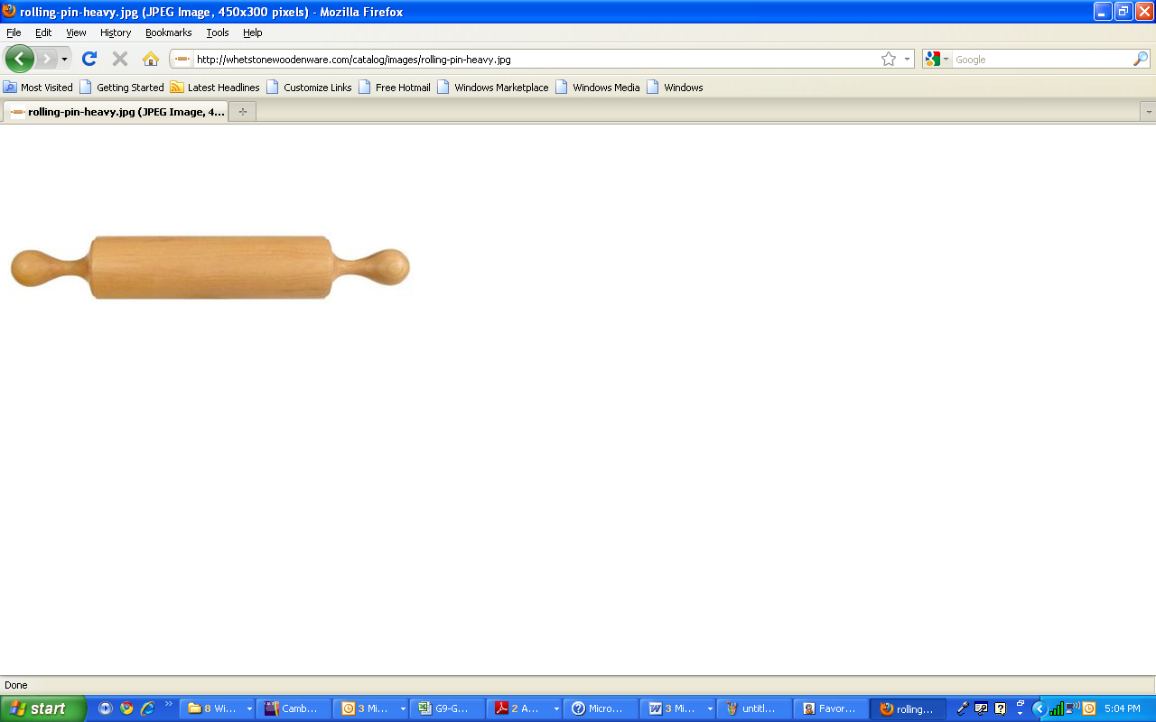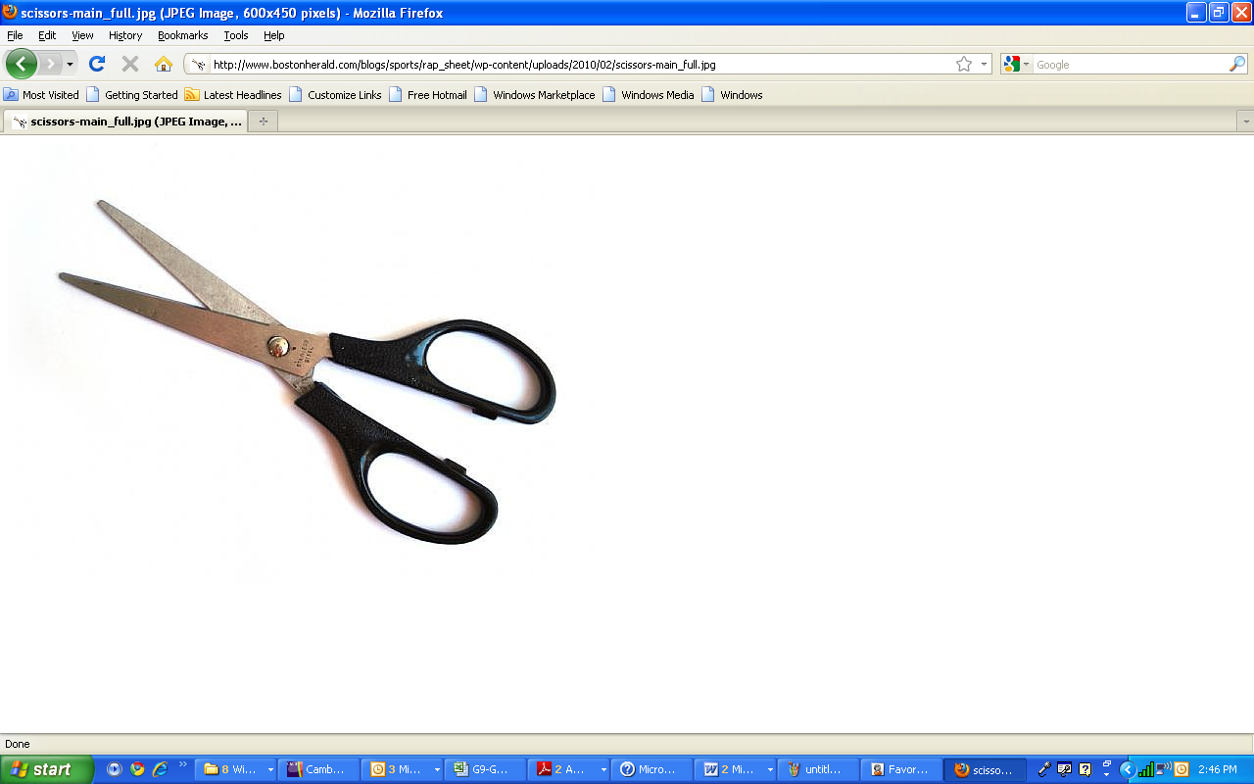

____________ ____________ __________

**Q/True or False**

1- Compound machine is a machine that consists of two or more simple machines put together. ( )

2- A clock mechanism can convert rotary motion to reciprocating motion. ( )

3- The fan is an example of a reciprocating motion. ( )

4- Mechanisms can be used to change the speed, direction or force needed to perform something. ( )

5- The mechanical advantage of a machine is the ratio of the output

force produced by a machine to the applied input force. ( )

6- To decrease the effort force we have to increase the effort arm length. ( )

7- Scissors are good examples for the second class of levers. ( )

8- Tweezers are typical example of third class levers. ( )

9- The Ideal Mechanical Advantage unit is meter(m). ( )

10- First class levers have the effort positioned in the middle between the load and pivot. ( )

11- Rotary motion is a back and forth swinging movement. ( )

12- Linear motion is a movement in a straight line. ( )

13- The wheel and axle will always rotate at the same frequency.

( )

14- Frequency is the number of cycles per minute. ( )

15- A door knob receive a manually applied force at one end (the axle end) and magnify the force at the other end (the wheel end) to complete the task. ( )

16- When the force transfer from the axle to the wheel, the wheels speed will increase. ( )

17- The mechanical advantage of a wheel and axle is the ratio of the wheel diameter to the axle radius. ( )

18- A simple machine is a mechanical device that changes the direction or magnitude of a force. ( )

19- Pulleys are wheels that are moved by ropes, cables, chains or belts around their rims. ( )

20- The direction of rotation of the pulleys depends on the size of the drive and driven pulley. ( )

21- The moveable Pulley is often fixed to an overhead beam and will only be able to rotate around its own axle. ( )

22- The Mechanical advantage of a fixed pulley is equal to 1mm. ( )

23-A compound pulley is made up of 1 or more pulleys. ( )

24- The main advantage of using a compound pulley is it travels a very long distance. ( )

25-Every two gears that mesh with each other move in opposite directions. ( )

26-The driven gear is the gear that is turned by an outside effort.( )

27- To move an object straight upwards with a shorter distance requires less effort than raising it up gradually for a longer distance. ( )

28- The MA of an inclined plane is the ratio of the distance load travels to the height the load is lifted. ( )

29- The Inclined plane could move but the wedge cannot. ( )

30- The finer the pitch of the screw, the more turns are required, but the less effort is needed to drive the screw in. ( )

31- The pitch of a screw is the number of threads per screw length. ( )

32- Archimedes was the first to use the wedge to move water for irrigation.

( )

33- The feather and wedge is an inclined plane used to cut large granite blocks.

**Q/Specify the types of motion in each picture**

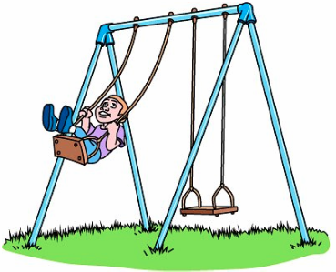 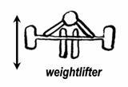

_________________ _____________________

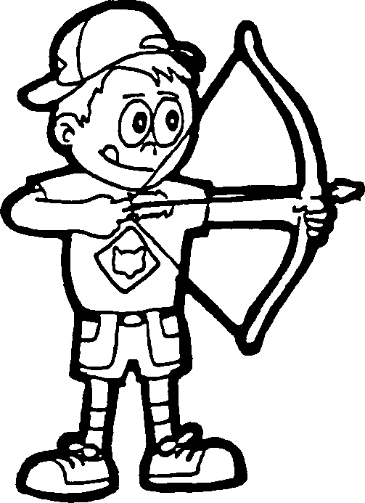 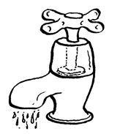

________________ _______________________

Q/Determine the class of levers of each of the following.

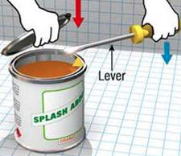 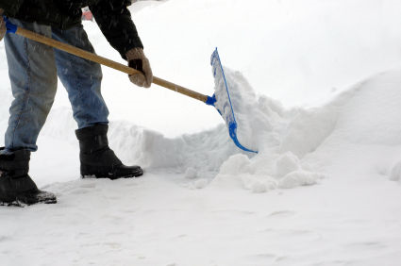 

___________________ ________________ ___________

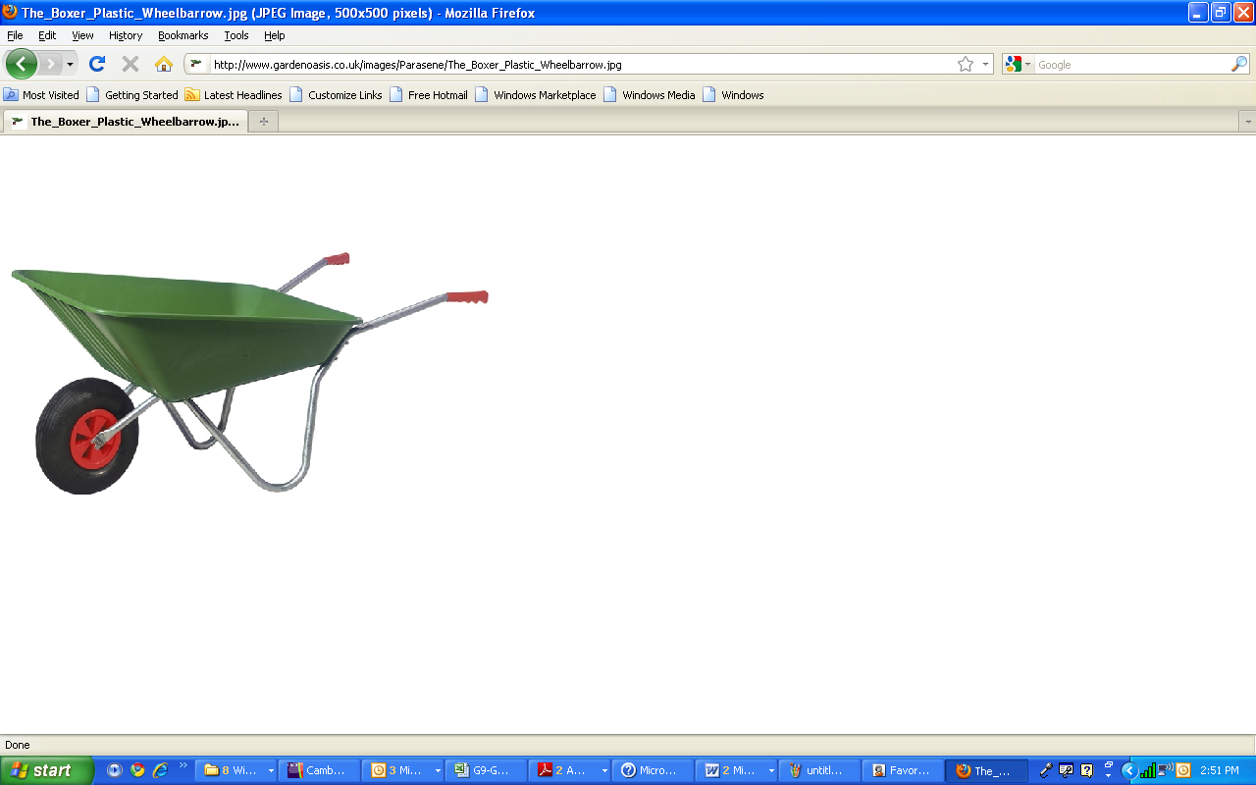  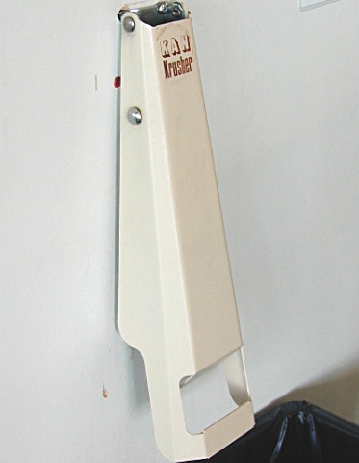

__________________ ______________ ___________

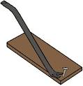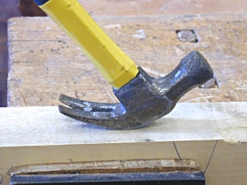 

___________ ____________ ____________

**Q/Draw the three classes of levers showing the position and the direction of load, effort and pivot.**

**Q/Write the correct explanation (magnify the force or increase the speed) beside each tool:**

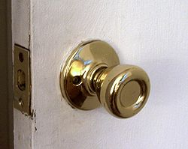 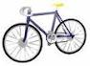

__________________ __________________

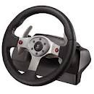

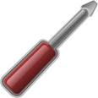

wheel

Axle

__________________ __________________

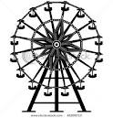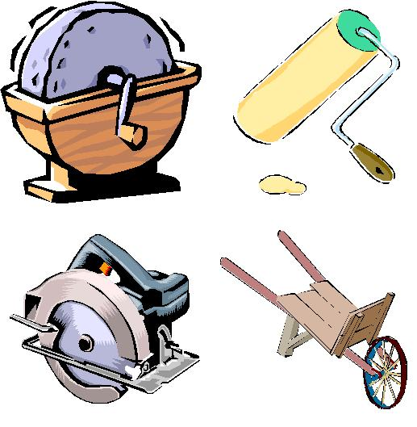

__________________ __________________

**Q/Match each picture with the matching word**

Fixed pulley Moveable pulley Compound pulley

Belt Driven Pulley Chain Driven pulley Rope Driven Pulley

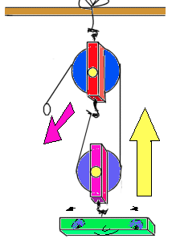 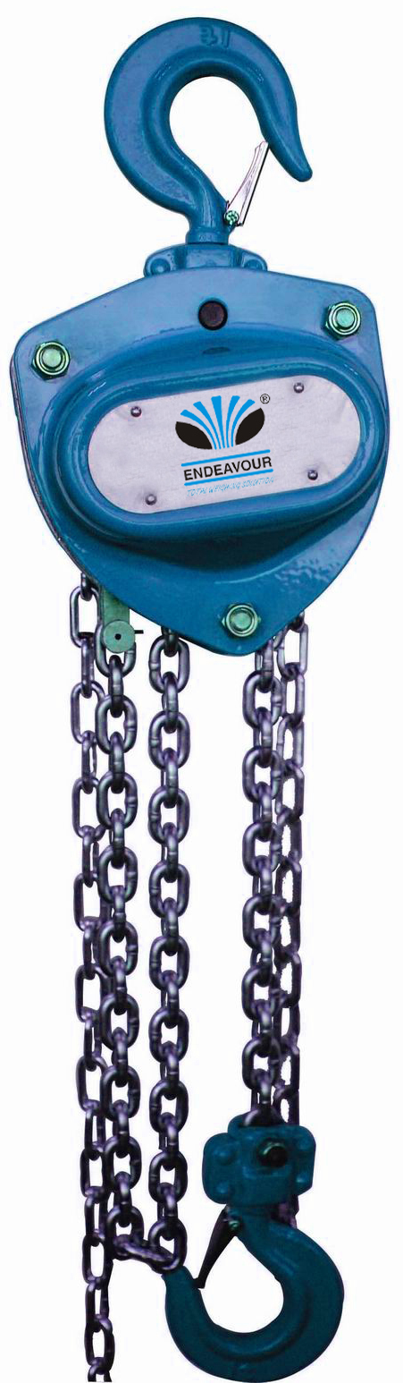 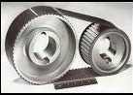

_______________ _____________ ________________

_______________ _____________ ________________

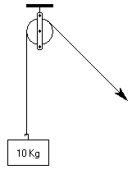 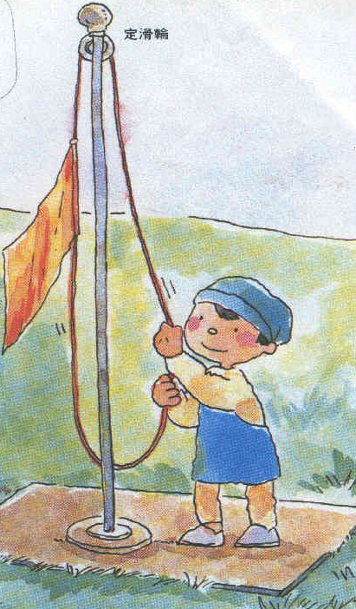 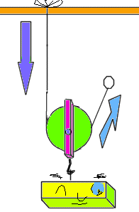

_______________ _____________ ________________

_______________ _____________ ________________

**Q/Tell whether the two pulleys have**

Same Speed or Different Speed

Same Direction or Different Direction

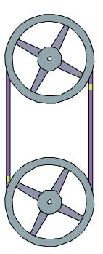 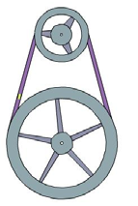 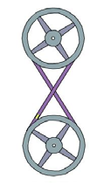

___________ ______________ ______________

___________ ______________ ______________

**Q/Solve the Below Exercises**

**Exercise 1**

Calculate the effort force needed to move a rock of 750 N, if the load arm length (1 m) and the effort arm length (5 m). Also calculate the Ideal Mechanical Advantage (*MAi*).



**5m**

**1m**

**750 N**

**Exercise 2**

A woman of weight 600 N wants to lift a man of weight 900N. The fulcrum is at a distance of 1m from the man.

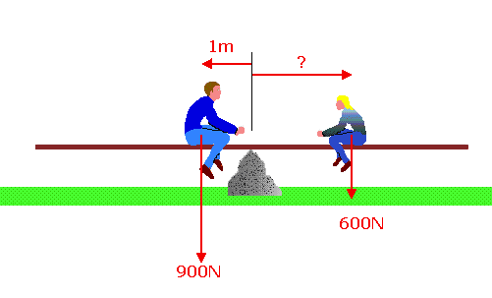

What should be the length of the rod from the fulcrum to the woman to lift the man?

__________________________________________________________________________________________________________________________________________________________________

Calculate the ideal mechanical advantage (***Mai***).

__________________________________________________________________________________________________________________________________________________________________

**Exercise 3**

|  |  |
| --- | --- |
| The baby bicycle shown in Fig. where the wheel diameter is 0.18 m and the axle diameter is 0.9 cm.  Calculate the mechanical advantage.  ____________________________  ____________________________  ____________________________ | Bicycle 2  Baby bicycle. |
| **Exercise 4**  The bicycle shown, calculate the mechanical advantage where,  Big wheel diameter: 82.8 cm  Small wheel diameter : 17.3 cm  Big axle diameter: 3.6 cm  Small axle diameter: 0.8 cm | Bicycle. |
| *MA* (big wheel)=  ____________________________  ____________________________ | *MA* (small wheel)=  _________________________  _________________________ |

**Exercise 5**

In the wheel and axle shown below, if the wheel diameter = 16 cm and the mechanical advantage (MA) = 8, calculate the diameter of the axle.

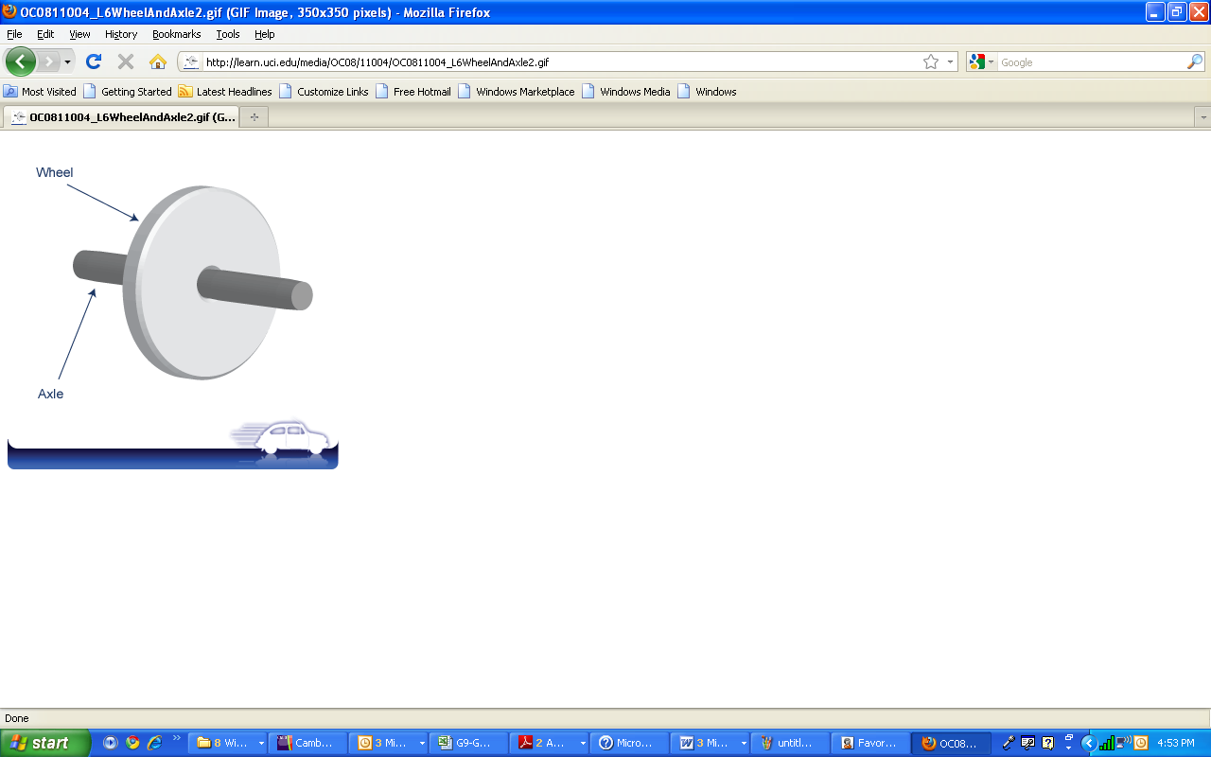

**Exercise 6**

Look at the image on the right. Gear "B" has 12 teeth and gear "A" has 24. Calculate the gear ratio of this gear train if "B" is the driver.  
If "B" turns 8 complete revolutions clockwise how many times will "A" rotate and in what direction?

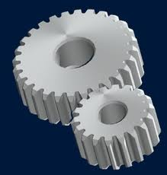

**B**

**A**

**Exercise 7**



1. Calculate the MA of the 2 above inclined planes.

__________________________________________________________________________________________________________________________________________

1. Find the effort force that is needed to raise a load of 120 N in both inclined planes, and then decide which plane requires the least effort?

__________________________________________________________________________________________________________________________________________

III. Suggest two methods to increase the mechanical advantage of the inclined plane.

__________________________________________________________________________________________________________________________________________

**Exercise 8**

Find the MA of the following Screw? Number of Thread= 60,

length =40 mm, shank =10 mm, d=5mm.

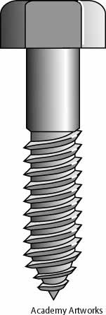

Shank

Length

Thread

**d**

**d**

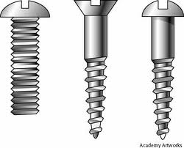**Exercise 9**

**For the screw shown in the fig., if d=0.5cm, calculate:**

1. **the pitch**

1 cm

**d**

1. **the mechanical advantage**

**Exercise 10:** **For the pulley system shown in fig., answer the questions:**

**A)** What is the maximum load that can be lifted with this system?

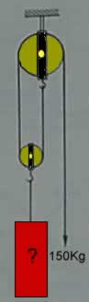

**10**

**kg**

1. What is the mechanical advantage?

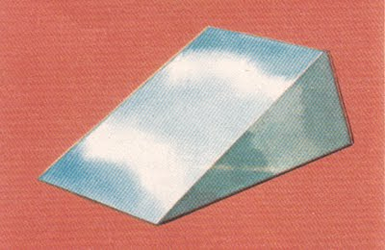**Exercise 11:** For the wedge shown in fig, answer the following questions:

1. **calculate the mechanical advantage**

**12 cm**

**5 cm**

1. **Which type of wedges? (single or two sloping surface)**

**Circle the correct answer.**

**1-**Which of the fallowing is not a simple machine?

1. Wedge
2. Pencil
3. Screw
4. Inclined Plain

2- Which one of the following levers will balance?

**22 N 15 N**

A.

**15 N 22 N**

B.

**22 N 15 N**

C.

D. **22N 15N**

3- Which one of the pulley systems shown below requires the highest effort to carry the same load?

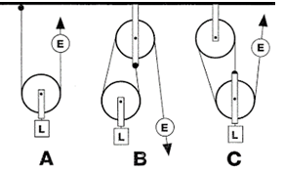

1. Pulley B
2. Pulley B&C
3. Pulley A
4. Pulley

4. The man in the figure shown below is using a to move the load.

1. 1st class lever
2. 2nd class lever
3. 3rd class lever
4. 4th class lever

5. Gears are used to transmit motion and to

1. Increase the speed
2. Decrease the speed
3. Change the direction of rotation
4. All the above

6. If the mechanical advantage of a lever is one (MA=1), this means that:

|  |  |  |
| --- | --- | --- |
|  | A. | The effort length is larger than the load length. |
| B. | The effort length is smaller than the load length. |
|  | C.  D. | The effort length is double the load length.  The effort length is equal to the load length. |

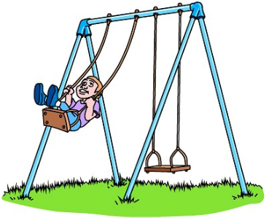7. the type of motion in the machine shown in the figure below is _______________ motion.

1. Oscillatory
2. Reciprocating
3. Rotary
4. Linear

8. A lever turns back and forth on a .

1. Fulcrum
2. Pulley
3. Effort
4. Load

9. A is made of two or more simple machines.

1. Lever
2. Wedge
3. Compound
4. Screw

10. in wedges, the effort you need depend on ________________

1. Length of the wedge
2. Width of the wedge
3. Sloping surface of the wedge
4. All the above