



**Technology Exploration-I**

Module 5:

Inclined Plane, Screws & wedges



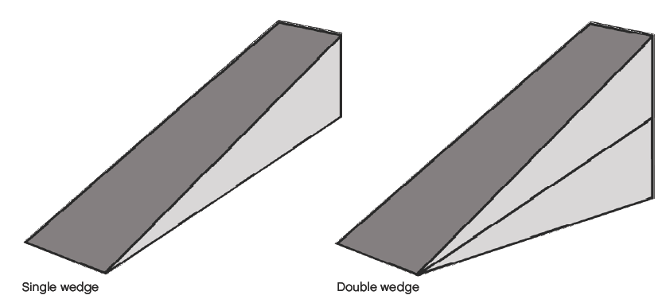

PREPARED BY

**Academic Services**

August 2011

© Applied Technology High Schools , 2011

Module 5:

Inclined Plane, Screws & Wedges

**Module Objectives**

After the completion of this module, students should be able to:

* Identify inclined planes, wedges and screws.
* Describe the purpose and application of each one of them.
* Calculate the mechanical advantage of inclined planes, wedges and screws.
* Conduct practical tasks to demonstrate the function of inclined planes, and wedges.

**Module Contents**

|  |  |  |
| --- | --- | --- |
| **No** | **Topic** | **Page** |
| 5.1 | Inclined Planes | 3 |
| 5.1.1 | Mechanical Advantage of the Inclined Plane | 6 |
| 5.1.2 | Practical Task 1 | 7 |
| 5.1.3 | Practical Task 2 | 8 |
| 5.2 | Wedges | 9 |
| 5.2.1 | Mechanical Advantage of the Wedge | 10 |
| 5.2.2 | Practical Task 3 | 11 |
| 5.2.3 | Practical Task 4 | 12 |
| 5.3 | Screws | 13 |
| 5.3.1 | Mechanical Advantage of the Screw | 15 |
|  | Worksheet | 17 |

|  |  |  |  |
| --- | --- | --- | --- |
| **5.1 Inclined Planes**  ***What is an inclined plane? How do they make our work easier?***  An inclined plane is a simple machine. **Definition**: It has a slanted surface used to move objects to another height with *less force* (figure 5.1). An example of an inclined plane is a ramp shown in figure 5.2. | | | |
| Fig 5.1: Inclined Plane | | | MC900057546[1]  Fig 5.2: Ramp |
| The advantage of using an inclined plane has been known for thousands of years. The ancient Egyptians used inclined planes to move the giant stone blocks easily to the top of the pyramids.  http://www.pyramid-building.eu/media/23bwanderndeRamp.jpg  Fig 5.3: Ramps used to build a pyramid | | | |
| Using an inclined plane to raise an object to a given height, the object must be moved a **longer distance, but with less effort needed.**  http://3.bp.blogspot.com/_QJ0r8pP-vUE/SUI7zvowJnI/AAAAAAAAAOw/BDRmOwIfIG4/s320/plane.jpg  Fig 5.4: Inclined plane demonstration  A lot of effort is needed to raise a given load a *short distance* **straight** upwards, whereas much less force is needed to raise it gradually **at an angle** over the *longer distance* of an inclined plane. Common examples of inclined planes are ramps, ladders and stairs. | | | |
| http://www.professorbeaker.com/images/ramp.gif | http://www.metalsucks.net/wp-content/uploads/2008/08/ladder.jpg |  | |
| 1. Ramp | 1. Ladder | 1. Stairs | |
| Fig 5.5: Inclined plane examples | | | |
| **Class Activity 1**  Think of other real-life examples of inclined planes. List at least three  __________________________________________________________  __________________________________________________________  __________________________________________________________  __________________________________________________________ | | | |

|  |
| --- |
| **Class Activity 2**  Solve the crossword puzzle by identifying the correct inclined plane example for each application described. |

|  |  |  |
| --- | --- | --- |
| **5.1.1 Mechanical advantage of an inclined plane**  The mechanical advantage of an inclined plane describes the *relationship between the length of the slope and the height of the inclined plane*. The mechanical advantage can be calculated using the following formula:    **MA = D / H**    Fig 5.6: The mechanical advantage of the inclined plane  For the illustration shown in figure, the mechanical advantage could be calculated as follows:  Mechanical Advantage (MA) = 3m/1m = 3  Calculating the effort needed to raise a known load can be done using this formula:  **Effort = Load/MA**  Calculating the effort needed to move a load is simple in theory. But in practice friction between the load and the surface of the ramp can affect the effort forces greatly. | | |
| **5.1.2 Practical Task 1:**  Refer to the building instructions booklet and build the D1 model of a short inclined plane as shown in Figure 5.7.    Figure 5.7: Inclined Plane-D1 model  Can the effort raise the load to the top of the inclined plane?  ___________________________________________________________  Add another wheel and try. What do you observe?  ___________________________________________________________  Calculate the Mechanical Advantage.  __________________________________________________________  **5.1.3 Practical Task 2:**  Now, build the D2 model as shown in Fig. 5.8.    Fig 5.8: Inclined Plane-D2 model  Comment on the length of this inclined plane when compared to the D1 model. Is this longer or shorter?  ___________________________________________________________  ___________________________________________________________  What about the angle of the ramp? Has it reduced or increased when compared to the D1 model?  ___________________________________________________________  Calculate MA. Is it higher than the MA of model D1?  ___________________________________________________________  Is the effort able to raise the load to the top of the inclined plane? If yes, give reasons.  ___________________________________________________________  ___________________________________________________________  **5.2 Wedges**  **Definition:** A wedge is a simple machine shaped like an inclined plane. Unlike an inclined plane a wedge can move.    Figure 5.9: Illustration of a single and double wedge  **Wedges are tools used to push two objects apart**. They can be used to split granite! A simple device called a wedge and feather can split huge granite blocks.  http://www.fhwa.dot.gov/environment/fspubs/84232602/fig04.jpg  Figure 5.10: Illustration of wedge and feather | | |
| A wedge can have a single or two sloping surfaces. The effort you need depends on the relationship between the length and width of the wedge and the sloping surface. Figure 5.11 shows examples of wedges. | | |
| http://www.dkimages.com/discover/previews/741/130868.JPG | http://www.sdslondon.co.uk/img/upload/products/2/l_94909.jpg | http://aggie-horticulture.tamu.edu/propagation/cleftgrafting/17.jpeg |
| (a)Axe | (b)Door wedge | (c) knife |
| Figure 5.11: Wedge examples | | |

|  |  |  |  |  |  |  |  |  |  |
| --- | --- | --- | --- | --- | --- | --- | --- | --- | --- |
| **Class Activity 3**  A carpenter needs to complete the following tasks in order to build a wooden chair. Help him choose between the inclined plane and the wedge to complete his tasks.   |  |  |  | | --- | --- | --- | | Task1 | Cut the tree | ____________________ | | Task 2 | Split the wood | ____________________ | | Task 4 | Transport logs of wood from the truck to the shop floor | ____________________ | |
| **5.2.1 Mechanical advantage of a wedge**  The mechanical advantage of a wedge can be calculated using the following formula:      Figure 5.12: The mechanical advantage of the wedge    The sharper the angle of the wedge, the more mechanical advantage it will have.  **5.2.2 Practical Task 3:**  Refer to the building instructions booklet and build the E1 model (book II, pages 16 to 25) of the wedge as shown in Fig. 5.13.    Fig 5.13: Wedge-E1 model  Calculate the mechanical advantage.  ___________________________________________________________  ___________________________________________________________  ___________________________________________________________  Push the wedge under the load. Explain what happens and why.  ___________________________________________________________  ___________________________________________________________  ___________________________________________________________  ___________________________________________________________  ___________________________________________________________  ___________________________________________________________  **5.2.3 Practical Task 4:**  Refer to the building instructions booklet and build the E2 model of the wedge as shown in Fig. 5.14.    Fig. 5.14: Wedge-E2 model  Turn the wedge around and calculate the mechanical advantage.  ___________________________________________________________  ___________________________________________________________  ___________________________________________________________  Then push the wedge under the load again. Explain what happens and why. Compare with the E1 model.  ___________________________________________________________  ___________________________________________________________  ___________________________________________________________ |

___________________________________________________________

|  |  |
| --- | --- |
| **5.3 Screws**  **Definition**: A screw is a modification of an inclined plane. The threads of a screw are like an inclined plane wrapped around a cylinder. The widths of the threads are like the angle of an inclined plane.  http://myword.info/images/sm_screw_1g.gif  Fig 5.15: Illustration of a screw  Archimedes, the Greek scientist, mathematician and inventor, used a screw as the basis for his screw-pump design to move water for irrigation  In the 3rd century BC.  http://www.school-for-champions.com/biographies/images/archimedes1.gif  Fig 5.16: Illustration of the Screw-pump  Common examples of a screw are different types of screws, cork screws and drills.    http://thirstconnection.co.uk/images/corkscrew.jpghttp://static.howstuffworks.com/gif/power-drill-1.jpg | |
| (a) Cork Screw | (b) Drill |
| Fig 5.17: Screw application examples | |
| The **pitch** is the *number of threads per cm of screw*. If a screw has 8 threads in a cm the screw has a pitch of 1/8. A screw with a pitch of 1/8 will in one complete revolution move a distance of 1/8 of a cm into an object.    Figure 5.18: Screw thread illustration  The screw has the following Specifications:   * The **finer** the pitch of the screw, the **more** turns are required, but the **less effort** is needed to drive the screw in. | |

|  |
| --- |
| **5.3.1 Mechanical Advantage of a Screw**  The mechanical advantage of using a screw involves the spreading of the effort over a longer distance thereby allowing heavy loads to be overcome with a smaller amount of effort. The mechanical advantage can be calculated using the following formula:    screw  Pitch  Diameter  Figure 5.15: Mechanical Advantage of a Screw  **Example**:  Calculate the Mechanical advantage for the screw shown below.  0.02 m    0.01 m  Pitch=0.01/3 m    This means if you can twist your screw driver with a force of 1N you can generate a force of 4N. |

**Student’s notes**

..................................................................................................................................................

..................................................................................................................................................

..................................................................................................................................................

..................................................................................................................................................

..................................................................................................................................................

..................................................................................................................................................

..................................................................................................................................................

..................................................................................................................................................

..................................................................................................................................................

..................................................................................................................................................

..................................................................................................................................................

..................................................................................................................................................

..................................................................................................................................................

..................................................................................................................................................

..................................................................................................................................................

..................................................................................................................................................

..................................................................................................................................................

..................................................................................................................................................

..................................................................................................................................................

..................................................................................................................................................

..................................................................................................................................................

..................................................................................................................................................

..................................................................................................................................................

**Worksheet**

1. What is an inclined plane? Give two examples.

_______________________________________________________

_______________________________________________________

_______________________________________________________

_______________________________________________________

1. Calculate the mechanical advantage (MA) of the inclined plane.

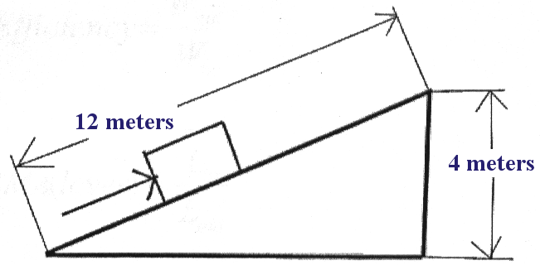

_______________________________________________________

_______________________________________________________

_______________________________________________________

_______________________________________________________

1. Calculate the mechanical advantage of a screw that has a radius of 0.01m and a pitch=1/2.

_______________________________________________________

_______________________________________________________

_______________________________________________________

1. Someone wants to slide a 100 pound crate up on an incline to a loading dock 4 feet above the ground. The inclination is 20 feet long. How much effort will it take to slide the crate up the incline?

_______________________________________________________

_______________________________________________________

_______________________________________________________

1. Find the mechanical advantage for the following.

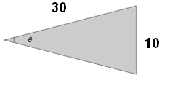

_______________________________________________________

_______________________________________________________

_______________________________________________________

1. Find the MA of the following Screw? Threads= 150, length =30 cm, shank =8 cm

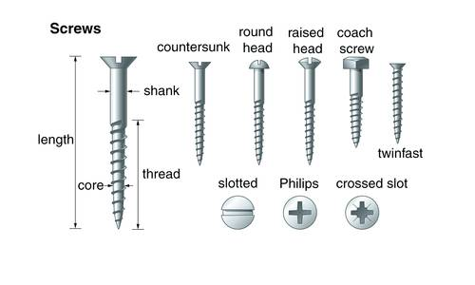_______________________________________________________

_______________________________________________________

_______________________________________________________

Question 7: Mark (T) for true and (F) for false statements.

|  |  |  |
| --- | --- | --- |
| **No.** | **Statement** | **T / F** |
| 1 | To move an object straight upwards with a shorter distance requires less effort than raising it up gradually for a longer distance. |  |
| 2 | As the distance of the inclined plane increases the effort needed decreases |  |
| 3 | Inclined planes are used to split things apart. |  |
| 4 | The Inclined plane could move but the wedge cannot. |  |
| 5 | The pitch of a screw is the number of threads per screw length |  |
| 6 | Screws are inclined planes wrapped around a cylinder |  |

Question 8: Identify the following pictures as Screw, Wedge or Inclined plane:

|  |  |
| --- | --- |
| [A slide is a common example of an inclined plane.](http://i.ehow.com/images/a05/jk/61/function-inclined-plane_-800X800.jpg) | http://www.mikids.com/SimpleMachines/doorlock.jpg |
|  |  |
| http://www.mikids.com/SimpleMachines/dumptr1.jpg | http://www.mikids.com/SimpleMachines/screwlid.jpg |
|  |  |