Levers and the Human Body
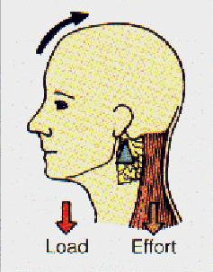

First Class Levers (LFE)

The best example of a first class lever in the body is found with the skull pivoting on the atlas vertebral of the spine, with weight of the head held by the trapezius and the muscles of the neck.

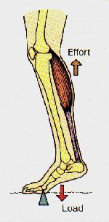

Second Class Levers (FLE)

The best example of a second-class lever is the action of the ball of the foot with the muscles of the calf lifting the weight of the body, which is acting through the foot.

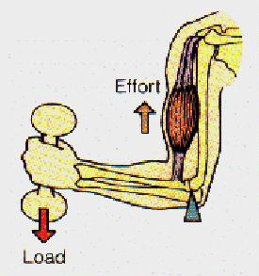
Third Class Levers (FEL)

Third class levers are commonplace in the body. A good example is the action of the bicep as it lifts a load in the hand whilst pivoting at the elbow.
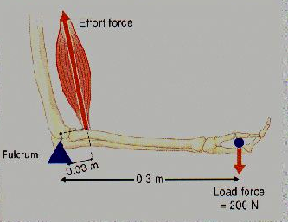
3rd Class Levers: A Mechanical Disadvantage

Due to the attachment of the muscle close to the fulcrum much more force (than the load force) must be generated to lift the load.

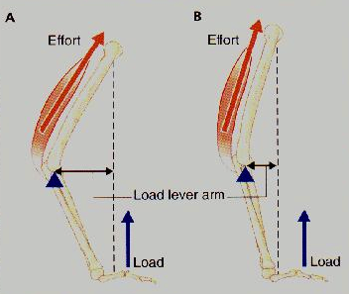
Does the angle effect the lever?

Working the levers at larger angles makes the muscle work much harder to overcome the load.

